Set-Up

The first time you deploy an image using VM Depot Easy Deploy, you will need to provide your Azure subscription details. This information can be [**readily obtained from Azure**](http://go.microsoft.com/fwlink/?LinkId=254432) once your subscription has been activated. Your browser will cache this information locally which means that while your first use of the Easy Deploy feature is simple, subsequent uses will be even easier. Note, however, that because the details are stored in your browser you will need to reconfigure them on each browser you use. If, for any reason, the authentication information contained within these settings are invalidated, the Easy Deploy web tool will prompt you to update them. You can also remove these settings from your browser cache, should you wish to do so (see Advanced Configurtion below).

The Deployment Process

For this exercise, we have elected to use WordPress3.5.1-Handson (distribution Centos). You may find that many other [**WordPress3.5.1-Handson**](https://vmdepot.msopentech.com/List/Index?sort=Date&search=name:WordPress3.5.1-Handson) images are available on VM Depot. The availability of both newer and older versions may be useful for testing purposes. The deployment process for any Virtual Machine image is the same regardless of which one you select.

Once you have identified a VM Depot image that you would like to deploy, click "Create Virtual Machine".

Set-Up VM Depot Easy Deploy

As discussed above, the first time you use the Easy Deploy feature, you will need to provide your Azure Subscription profile settings. Simply drag and drop the appropriate file ([**download it from Azure**](http://go.microsoft.com/fwlink/?LinkId=254432)) onto this page (or click to browse to the file). A link to download your publish settings file will also be conveniently provided on this page should you need to re-download it at any point in the future.

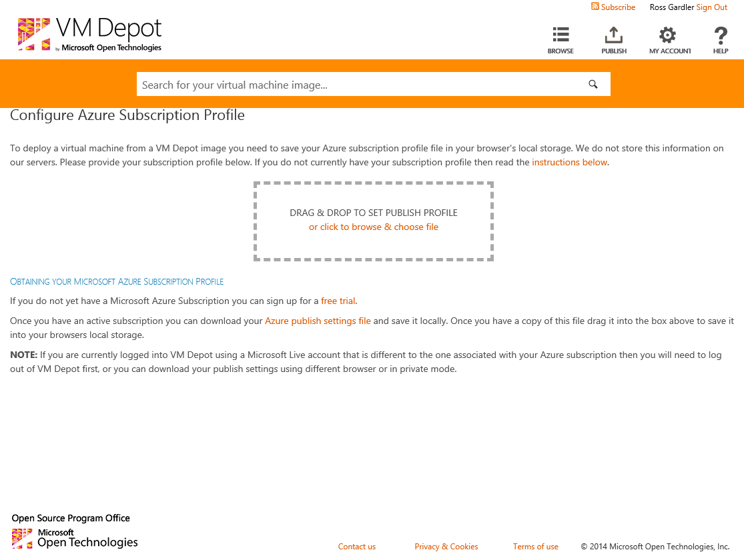

Configure Your Virtual Machine

On the deployment configuration page, you will be required to, at a minimum, provide a password for the default "azureuser" account and accept the terms of use. You can also see (and change) values for the DNS name and username. In addition, the default VM name (the name used in Azure to manage the image), VM Size and deployment region, are displayed. If you want to change these simply click them.

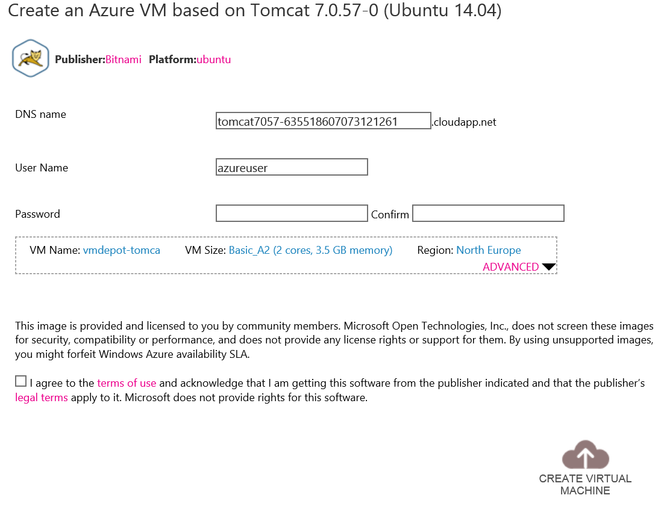

An important item to call to your attention: the username specified here is not the username for the WordPress3.5.1-Handson application; it is the default user on the Linux VM. This means that you will use this username to login to the Linux virtual machine itself. The image description on VM Depot should contain any required usernames and passwords.

You may also click on the “Advanced” link to access additional configuration options. More information about these options is detailed in the [**next section**](https://vmdepot.msopentech.com/tutorial/deploy/367.html/#advancedconfig) of this tutorial.

Virtual Machine Creation

After you have read and accepted the terms and conditions, you should click “Create Virtual Machine” to schedule the creation of your VM. Doing so will generate the following confirmation page, which also includes status information. Once you arrive at this page, you have completed all the deployment steps. An email will notify you when your VM is ready to be used (usually within 5-15 minutes).

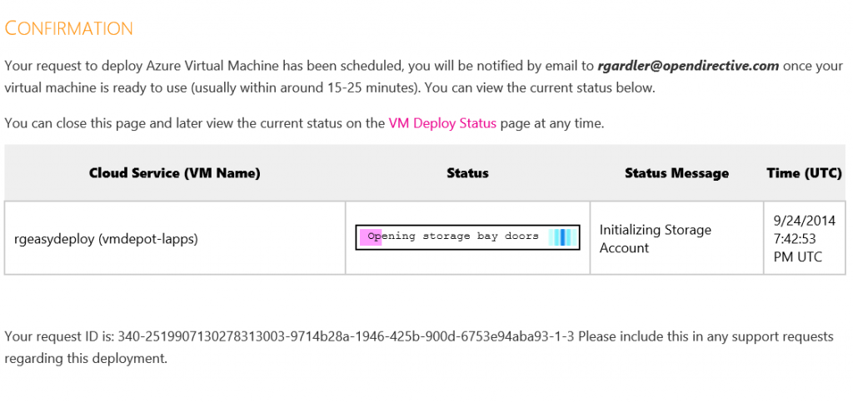

For the curious, the confirmation page shows real-time status updates pertaining to your deployment. You may return to this page at any time by selecting "VM Deploy Status" within the "My Account" sidebar menu on the left side of the screen (which will only be available if you are currently logged in. This page will tell you the current status of your VM both during and after deployment. That is this page will later be used to review which VMs are currently running.

Advanced Configuration Options

As noted above, you may also take advantage of several advanced options. You can change the default settings before launching your image by clicking on the “Advanced” link on the configuration page. The screenshot below illustrates the available options:

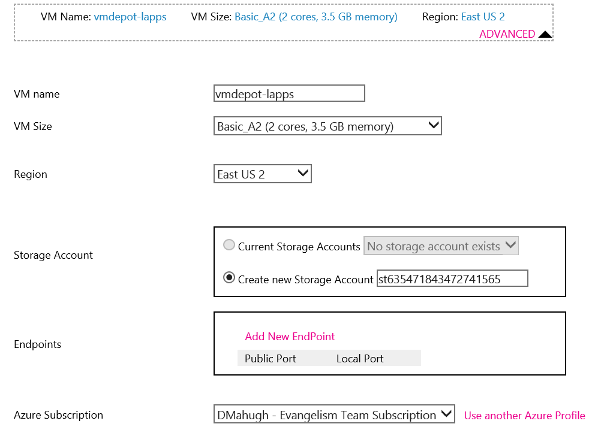

Most users will only have one subscription associated with their account. If you have a Microsoft account with multiple Azure subscriptions enabled, each will be listed within the "Azure Subscription" dropdown at the bottom of this section. It is advisable that you first make changes to this, if you plan to do, as many of the other options depend on the selection here. If you wish to use a subscription not listed, then select the “Use another Azure Profile” link to remove the current settings from the cache and provide a new Azure Publish Settings file.

The “VM Name” field defines the name assigned to the VM in Azure. The portal and other management tools use this value to identify the VM to the user. The default names provided may not be very descriptive, but they are often sufficient for a small number of VMs. For those who wish to do so, you may configure a more memorable VM name here.

“VM Size” refers to the size of the Virtual Machine you wish to create, in terms of processor, memory, disk size and maximum IOPS. Descriptions of the codes used within this field are available in the Azure documentation on [**Virtual Machine Sizes for Azure**](http://msdn.microsoft.com/en-us/library/azure/dn197896.aspx).

The “Region” field specifies which data-center you wish to deploy to. The dropdown contains all valid regions for your deployment.

The default “Storage Account” is the first attached to your subscription. If you prefer to use a different account, simply select it from the options provided within the dropdown menu. Alternatively, you may create a new storage account using the text box provided.

Lastly, VM Depot Easy Deploy will automatically open any “Endpoints” defined by the publisher as being necessary. In the majority of cases, this setting will remain unchanged. If you have specific requirements, you have the option to add or remove endpoints, as needed.